**WEEK-3**

**NAME- SANCHIT JAIN**

**ENROLL – 21103192**

**BATCH – B-7**

#include<iostream>

#include<cmath>

using namespace std;

class triangle{

    int a,b,c;

    public:

    void initialize(){

        a= 3;

        b= 4;

        c =5;

    }

    void perimeter(){

        int perimeter;

        perimeter = a+b+c;

        cout<<"The perimeter is = "<<perimeter<<endl;

    }

    void area(){

        float s = (a+b+c)/2.0;

        float area = sqrt(s*(s-a)*(s-b)*(s-c));

        cout<<"the area is = "<<area<<endl;

    }

};

int main(){

    triangle t;

    t.initialize();

    t.perimeter();

    t.area();

    return 0;

}

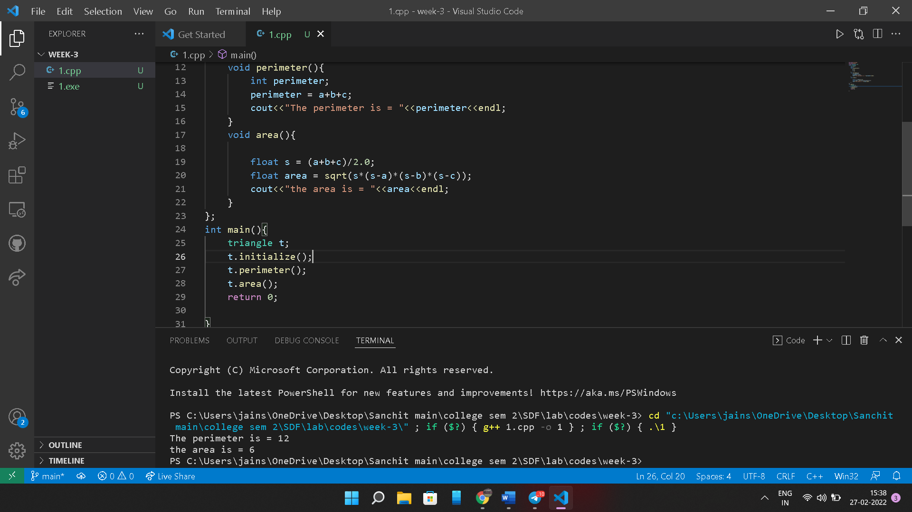

**2.** #include<iostream>

#include<cmath>

using namespace std;

class trianlge{

    public:

    int a,b,c;

    trianlge(int a,int b,int c){

        this->a = a;

        this->b= b;

        this->c = c;

    }

     void perimeter(){

        int perimeter;

        perimeter = a+b+c;

        cout<<"The perimeter is = "<<perimeter<<endl;

    }

    void area(){

        float s = (a+b+c)/2.0;

        float area = sqrt(s*(s-a)*(s-b)*(s-c));

        cout<<"the area is = "<<area<<endl;

    }

};

int main(){

    trianlge t(3,4,5);

    t.area();

    t.perimeter();

}

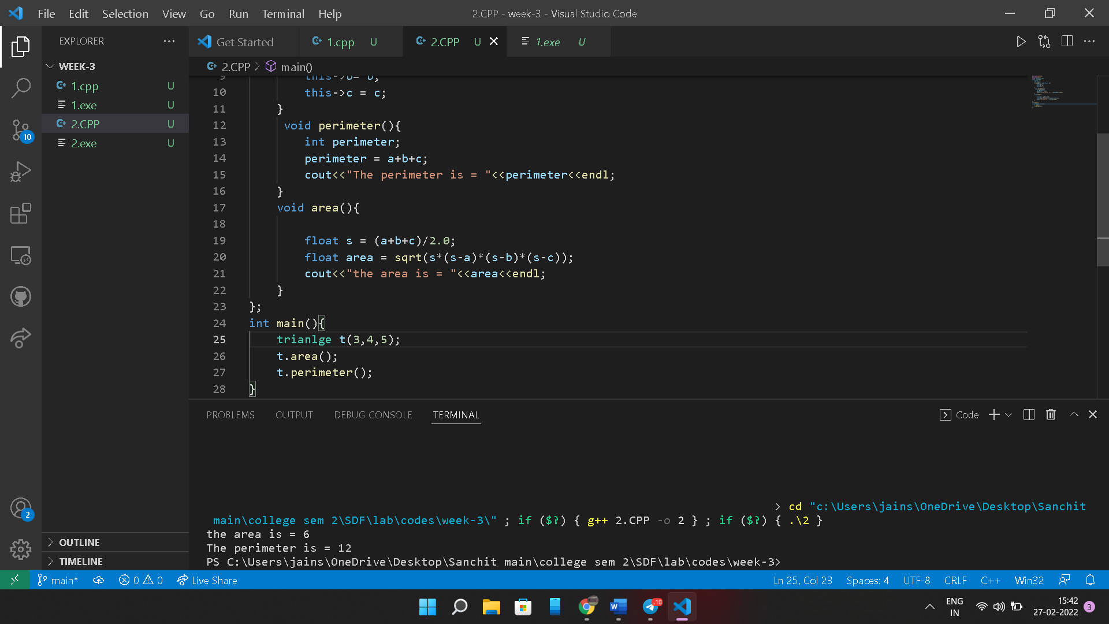

**3.** #include <iostream>

#include <cmath>

using namespace std;

class complex

{

    float realPart;

    float complexPart;

public:

    complex(float real, float complex)

    {

        realPart = real;

        complexPart = complex;

    }

    float getRealPArt()

    {

        return realPart;

    }

    float getComplexPart()

    {

        return complexPart;

    }

    void sum(complex c2)

    {

        cout << "Sum is :" << (realPart + c2.getRealPArt()) << " + " << (complexPart + c2.getComplexPart()) << "i" << endl;

    }

    void subtract(complex c2)

    {

        cout << "Difference is " << (realPart - c2.realPart) << " + " << (complexPart - c2.complexPart) << "i" << endl;

    }

    void multiply(complex c2)

    {

        cout << "Product is " << ((realPart * c2.realPart) - (complexPart * c2.complexPart)) << " + " << ((realPart * c2.complexPart) + (complexPart * c2.realPart)) << "i" << endl;

    }

};

int main(){

    complex c1(3.0,4.0),c2(4.0,5.0);

    c1.sum(c2);

    c1.subtract(c2);

    c1.multiply(c2);

}

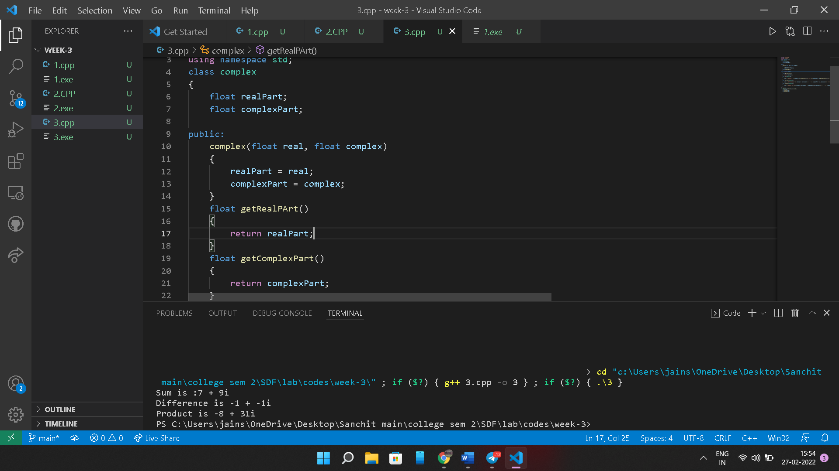

**4.** #include<iostream>

#include<cstring>

using namespace std;

class first{

    char name[30];

    public:

    void setName(char * name2){

        strcpy(name,name2);

    }

    void printName(){

        cout<<"The name is "<<name<<endl;

    }

};

int main(){

    char name[] = "Sanchit Jain";

    first t;

    t.setName(name);

    t.printName();

    return 0;

}

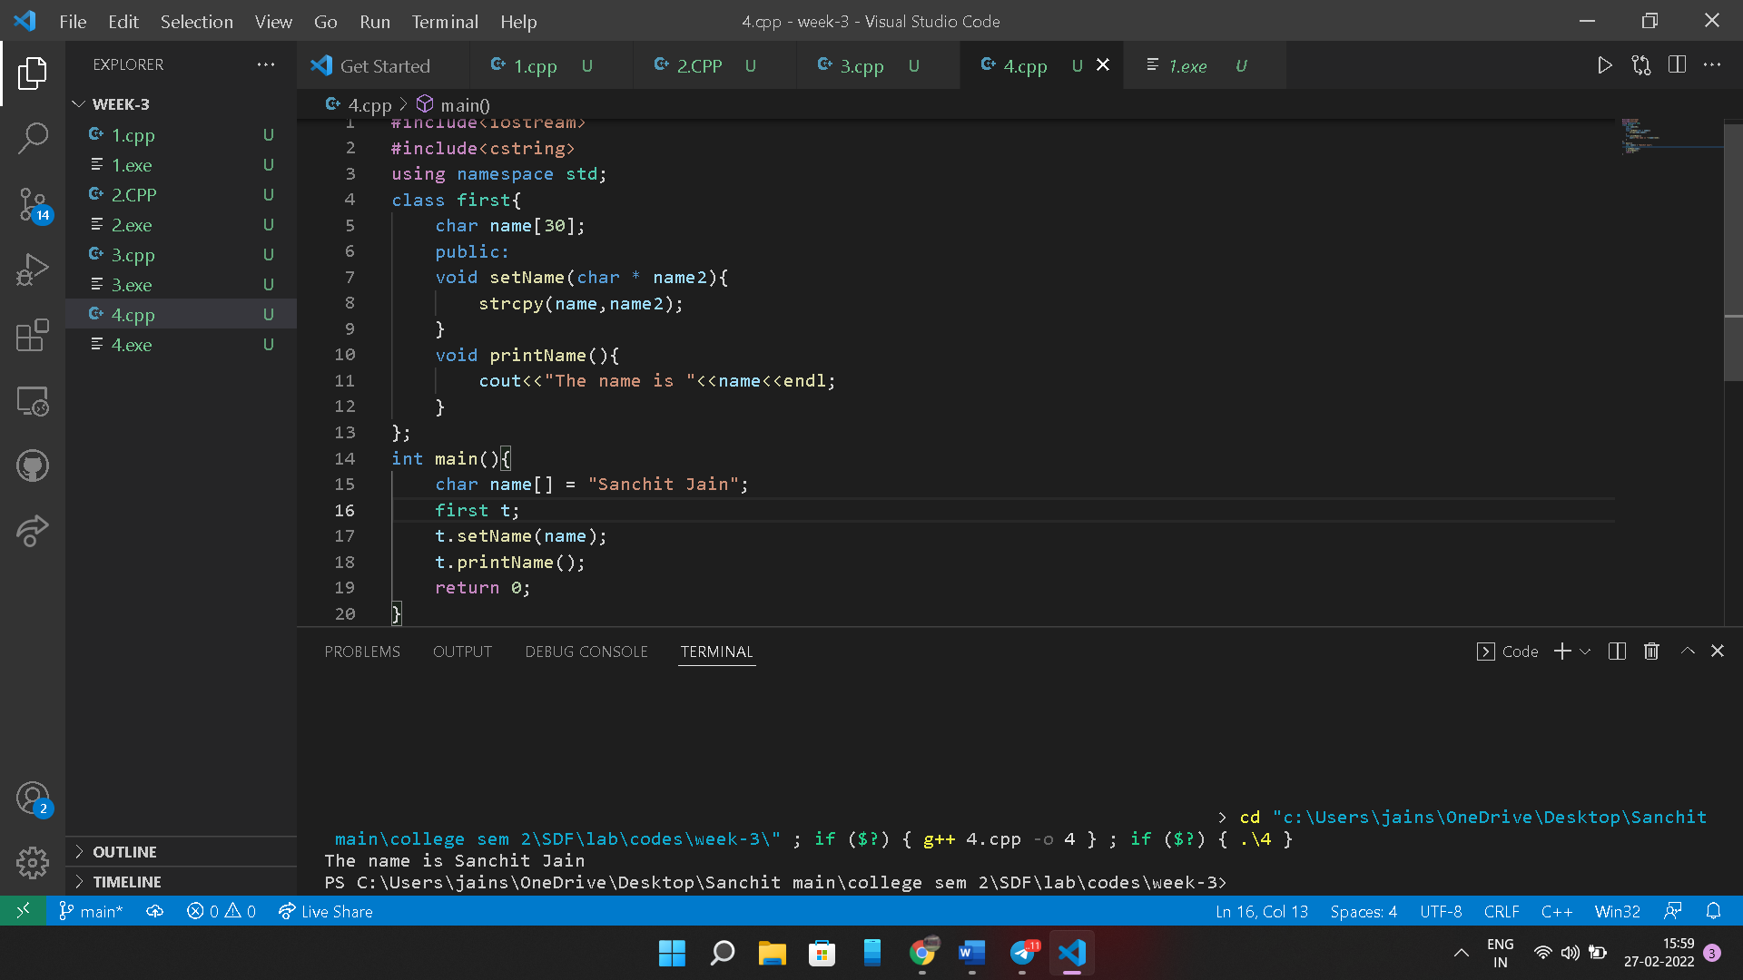

**5.** #include<iostream>

#include<cstring>

using namespace std;

class id{

    public:

    int number;

    id(){

    }

    id(int id1){

        number=id1;

    }

    void printID(){

        cout<<"The id is :"<<number<<endl;

    }

};

int main(){

    id id1,id2(18);

    id1.number=27;

    id1.printID();

    id2.printID();

    return 0;

}

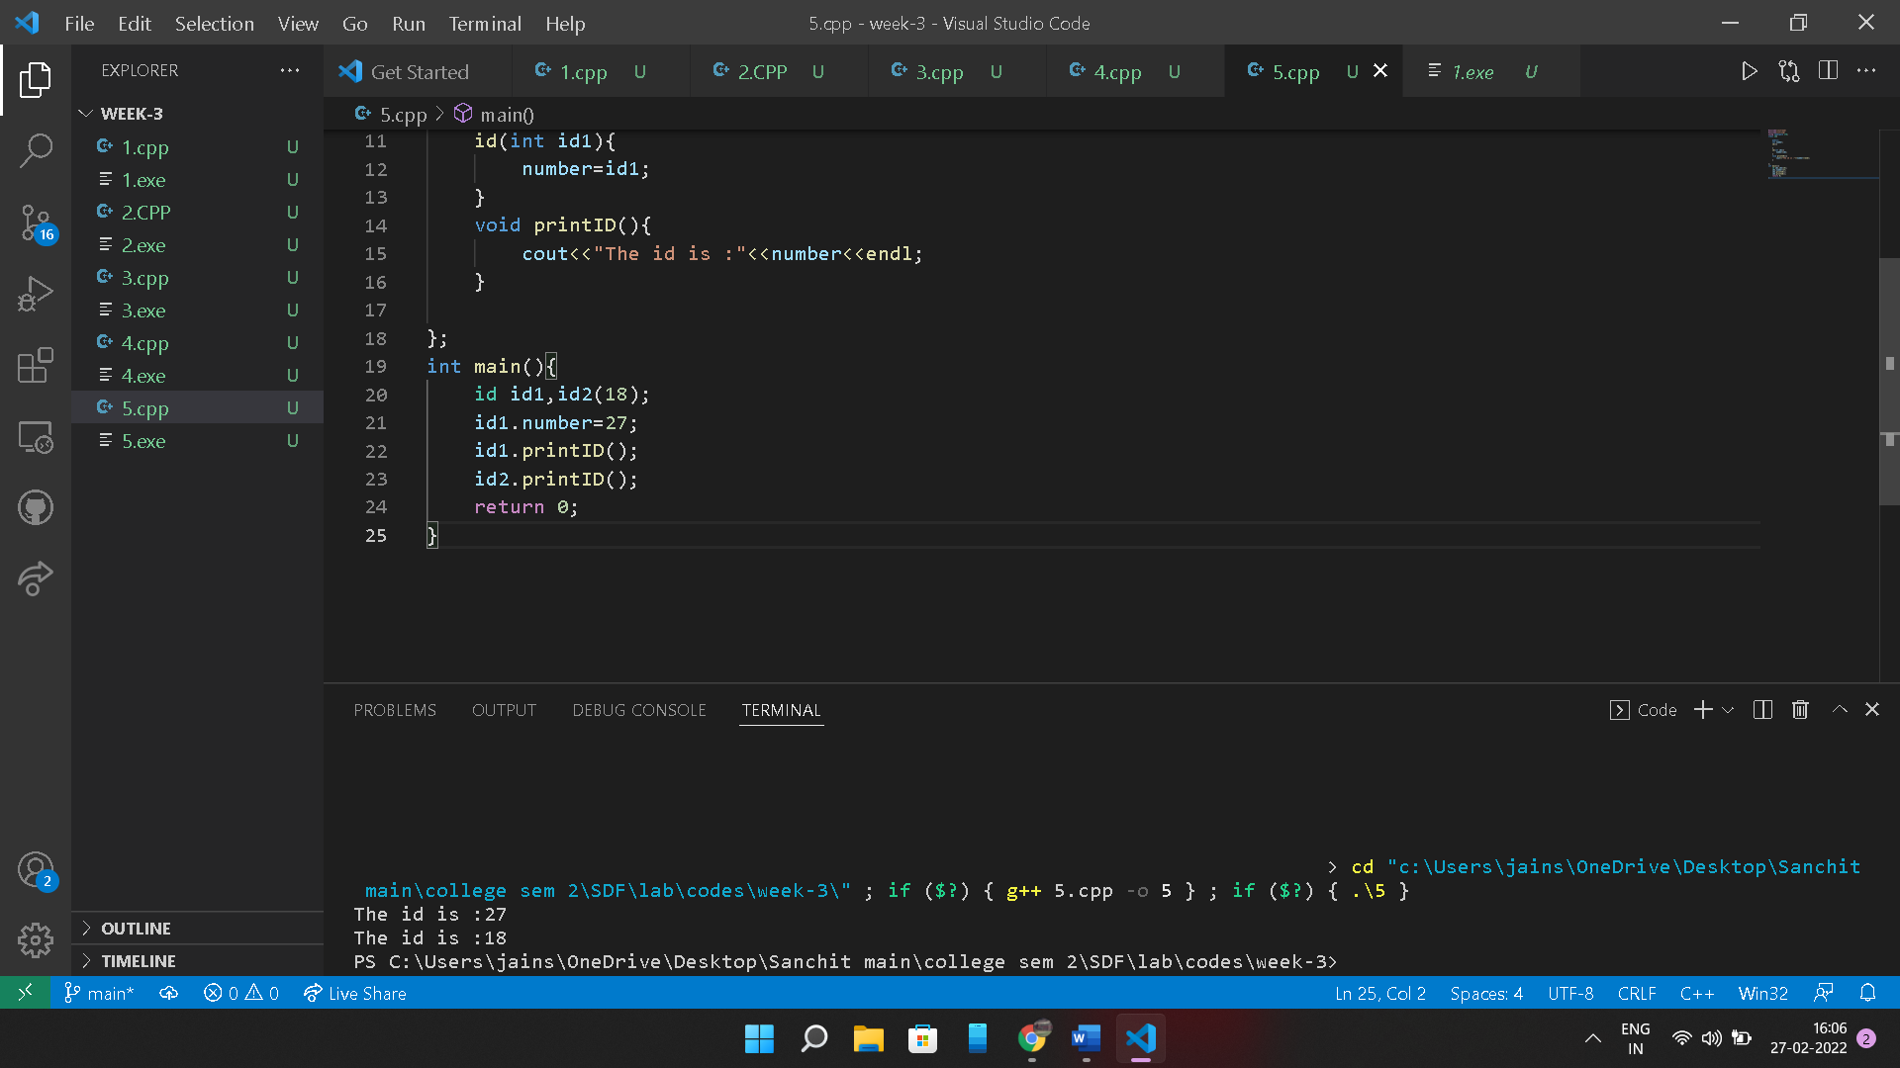

**6.** #include<iostream>

using namespace std;

class rectangle{

    int length,breadth;

    public:

    void set(int l,int b){

        length=l;

        breadth=b;

    }

    int area(){

        return length*breadth;

    }

};

int main(){

    rectangle r;

    r.set(10,50);

    cout<<"Area of rectangle is :"<<r.area()<<"unit square"<<endl;

    return 0;

}

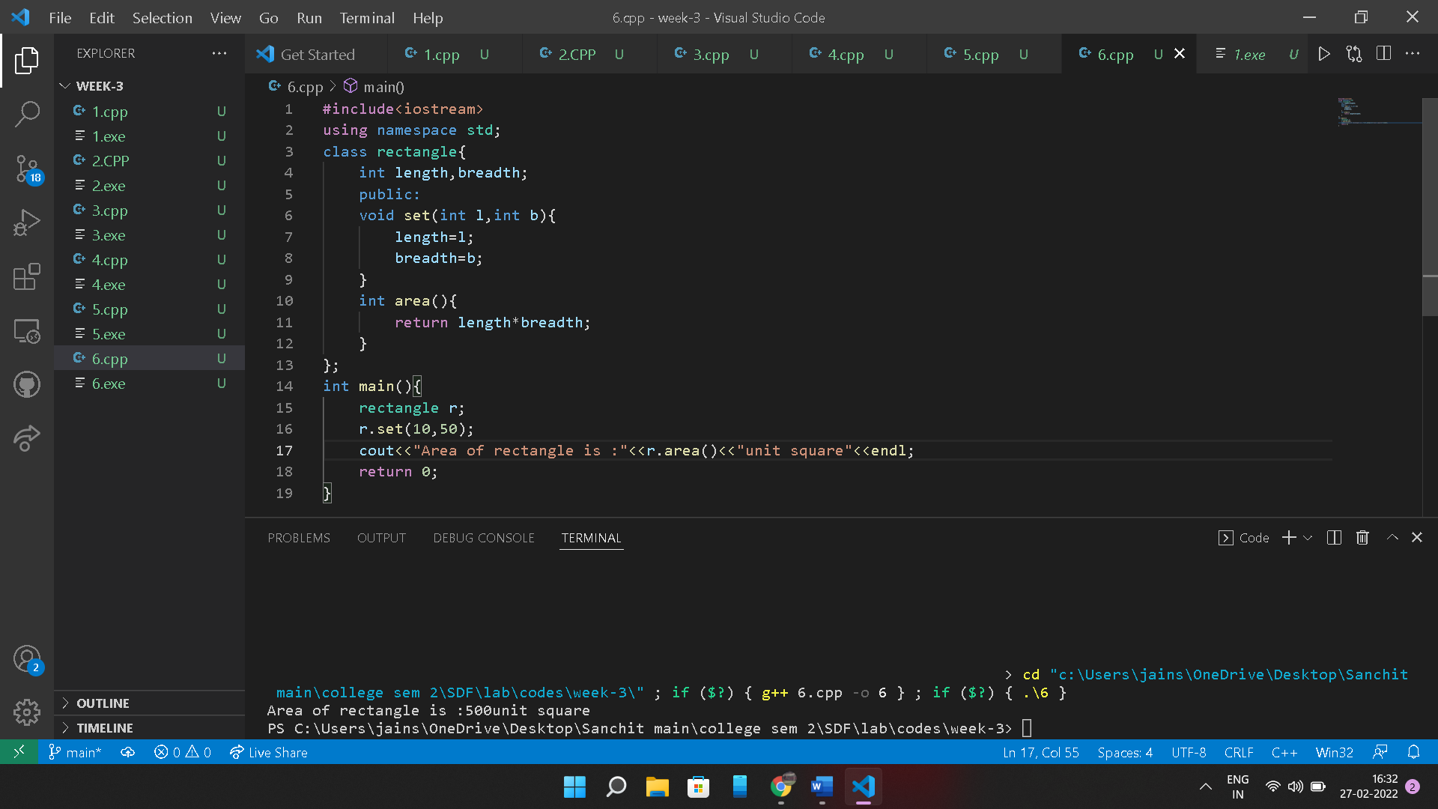

**7.** #include<iostream>

using namespace std;

class student{

    int marks;

    public:

    student(int m){

        marks=m;

    }

    int average(student m1){

        return (marks+m1.marks)/2;

    }

    int average(student m1,student m2){

        return (m1.marks +m2.marks)/2;

    }

};

int main(){

    student m1(10),m2(20);

    cout<<m1.average(m2)<<endl;

    cout<<m1.average(m1,m2)<<endl;

}

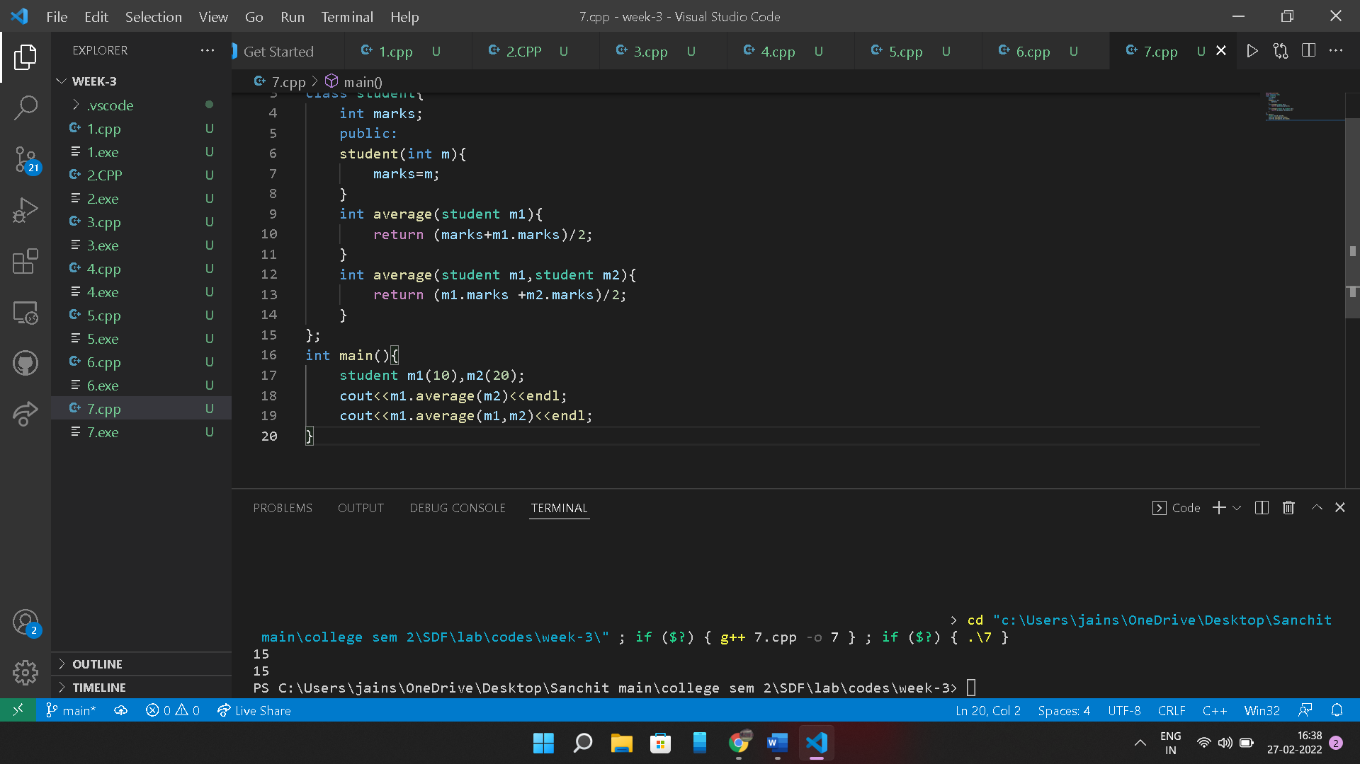

**8.**

#include <iostream>

#include <cstring>

using namespace std;

class Student

{

private:

    int enrollmentNumber;

    char name[20];

    char branch[4];

    float cgpa;

public:

    Student(int en, char *na, char *br, float cg)

    {

        enrollmentNumber = en;

        strcpy(name, na);

        strcpy(branch, br);

        cgpa = cg;

    }

    Student(int en, char *na, float cg)

    {

        enrollmentNumber = en;

        strcpy(name, na);

        strcpy(branch, "CSE");

        cgpa = cg;

    }

    Student()

    {

        enrollmentNumber = 1;

        strcpy(name, "Unknown");

        strcpy(branch, "ECE");

        cgpa = 7.0;

    }

    int getEnrollmentNumber()

    {

        return enrollmentNumber;

    }

    char *getName()

    {

        return name;

    }

    char *getBranch()

    {

        return branch;

    }

    float getCGPA()

    {

        return cgpa;

    }

    void setEnrollmentNumber(int eno)

    {

        enrollmentNumber = eno;

    }

    void setName(char *name2)

    {

        strcpy(name, name2);

    }

    void setBranch(char *br)

    {

        strcpy(branch, br);

    }

    void setCGPA(float cg)

    {

        cgpa = cg;

    }

};

int main()

{

    char name[] = "Sanchit Jain";

    char branch[] = "CSE";

    Student s1(1, name, branch, 8.7);

    Student s2(2, name, 8.7);

    Student s3;

    cout << "Details of Student 1: ";

    cout << s1.getEnrollmentNumber() << " " << s1.getName() << " " << s1.getBranch() << " " << s1.getCGPA() << endl;

    cout << "Details of Student 2: ";

    cout << s2.getEnrollmentNumber() << " " << s2.getName() << " " << s2.getBranch() << " " << s2.getCGPA() << endl;

    cout << "Details of Student 3: ";

    cout << s3.getEnrollmentNumber() << " " << s3.getName() << " " << s3.getBranch() << " " << s3.getCGPA() << endl;

    s1.setCGPA(9.1);

    s2.setCGPA(9.0);

    s3.setCGPA(8.9);

    cout << "Details of Student 1: ";

    cout << s1.getEnrollmentNumber() << " " << s1.getName() << " " << s1.getBranch() << " " << s1.getCGPA() << endl;

    cout << "Details of Student 2: ";

    cout << s2.getEnrollmentNumber() << " " << s2.getName() << " " << s2.getBranch() << " " << s2.getCGPA() << endl;

    cout << "Details of Student 3: ";

    cout << s3.getEnrollmentNumber() << " " << s3.getName() << " " << s3.getBranch() << " " << s3.getCGPA() << endl;

    return 0;

}

